*Project Senna*

Proposal

A program-controlled race car learns (using a genetic algorithm) how to find the fastest time round a track, and the user can choose to race any specific generation (skill level) of the AI to race against on each track.

I would find it interesting since I have a passion for cars and racing, I think it would be cool to be able to see how an AI goes about finding time around a track, and how it may act differently to a human trying to learn how to be the fastest. I’m not sure whether to do it in 3D or 2D yet but if I were to do it in 3D it would be a great way to learn the skills within 3D graphics.

It would require a decent knowledge behind the math’s and computation behind a self-learning algorithm, since I want to implement it from scratch (without any external libraries). The project would also need specific attention to speed since ideally there would be loads of cars (controllers) learning at the same time, so learning optimization strategies for the language I use will be key.

I do believe that it’s a feasible idea, since the complexity can range from simple to extremely complex, i.e. I can build up to the harder complexity stuff when the base project is working, without ruining the original concept.

After doing some brief research online, I found a number of other implementations of this AI experiment : for example **Code Bullet** on YouTube <https://www.youtube.com/watch?v=r428O_CMcpI&t=860s&ab_channel=CodeBullet> , and numerous examples on github.com. However, I have yet to see a implementation which boasts realistic, more complex controllers such as a **clutch system**, **standard 6 speed gearing**, or **rpm consideration.** Additionally, with a **PLAY against the AI** system I think this project would provide a unique and more engaging spin on this machine learning simulation.

*Possible machine learning algorithms*

1. Genetic algorithm with Neural Network – this is my number one pick, since it curiously reproduces the learning behaviour of a human which is particularly entertaining to watch. It also allows for an infinite amount of optimization and customization in the way the neural network is modified and improved which makes this a desirable method for development. Finally, this technique is relatively simple to implement as you avoid a large amount of the frankly painful maths attached to other machine learning algorithms.
2. Classic Reinforcement learning ( Q-learning ) – a very efficient and optimal algorithm for this project. It involves a predetermined environment, a set of actions and a set of rewards which are distributed to each controller to **reinforce** their behaviour if they are seeing success or to **discourage** suboptimal behaviour. However, this technique is particularly complex, requiring huge amounts of very complicated maths and optimization algorithms to work properly. Therefore, I will reject this approach due to its dubious feasibility at this stage of my computer science development.

**SO Genetic Algorithm approach is my algorithm of choice!**

*Stakeholders*

I predict my stakeholders to be students or young adults with an interest in AI and environmental simulations, with particular interest in motorsport. My application will provide a fun and interactive experience with machine learning, which will hopefully inspire other young developers to experiment with the somewhat ominous field of computer science and to create their own simulations. Teachers and tutors could use my project to introduce basic self-learning techniques and the **RACE against** feature should keep students engaged and entertained while learning.

Additionally, when the AI controllers eventually optimize their lap times, their strategies to traverse the track may unveil new or reinforce preexisting notions about motorsport. Therefore, depending on the results of the simulation – my simulation may be utilized by novice motorsport teams to demonstrate optimal racing lines to their racers.

*Requirements*

Importance Level:

* Critical
* Would be nice
* Polishing touch

|  |  |  |  |
| --- | --- | --- | --- |
| Feature | Description | Importance | WHY? |
| App must have a UI | Track and cars drawn onto the graphics window | Critical | App needs a graphics interface to illustrate the simulation in action |
| Main menu | Have choice to start a new simulation | Critical | App requires a interface so user can start a simulation |
| AI controllers | Have each car controlled by a neural network controller which takes in environment data and outputs an action | Critical | Pretty self explanatory |
| Option to select a racer | Select a racer should display a window of stats and info about that controller | Would be nice | Not totally necessary but really useful for development and allows interactivity |
| Random track generation | Option to choose a new **random map,** should use algorithm to generate a new useable track. | Would be nice | Would be very useful and interesting to see how a controllers skill transfers between tracks |
| Save and load previous controllers | Provides an option for user to save a current controller (racer) or load an old controller | Polishing touch | Again, not essential but a lovely touch and saves time during my development |
| Cars should have movement physics | Allow interface for controller to move the car how they want, accelerate, brake, shifting etc. | Critical | Very self-explanatory, cars need a way to move around the track |
| Timing and checkpoint system | Stopwatch system which times AI cars throughout sectors and gives these times back as feedback | Critical | This is the way AI controllers gain feedback and thus learn and improve |
| Neural network and genetic algorithm | Implementation of neural networks and genetic algorithm used to optimize the network’s weights and sizes. | Critical | How the AI **learns** this is perhaps the most critical feature, its required for the simulation to successfully run. Probably the most time consuming step of development |
| Pause / Play feature | Feature which allows user to stop and start the simulation during runtime | Would be nice | Useful device for development and also for user’s wanting to inspect a controller’s data at a single point in time. |
| Leaderboard | Display section which shows a list of the fastest racer’s | Polishing touch | Can tell user which AI racer to watch and inspect. |

*Limitations*

|  |  |
| --- | --- |
| Limitations | Explanation |
| Runtime speed | For large population generations of controllers, depending on individual hardware performance. |
| The UI | The library I’m using for UI design is slightly limited so the UI may be a little limited but for a simulation this isn’t really a big deal. |
| Car Physics | The car physics in this game will, naturally, be quite inaccurate since modelling the actual physics of the car would be a bit redundant and kill run speeds. |

*Hardware requirements?*

* The only requirement is a computer with enough hardware to run a moderately heavy application – should run smoothly on any computer produced after the 2000’s. There are no specific hardware or software requirements since the project will be packaged as a simple .exe file.

***Computational Methods***

* *What makes this project suitable for a computer:*

1. The simulation is easily decomposable into a series of features which need to interface with each other to run
2. Large amounts of arithmetic operations need to be run in milliseconds, perfect for a computer. This includes the genetic algorithm manipulating the neural network’s parameters and vast linear algebra calculations required to ‘run’ through the neural network. These operations happen hundreds of times a second for every controller on the screen – therefore a computer is not only useful but **required** to run this experiment.
3. Visualization is an integral component to my project since the user’s must be able to watch along as the AI controllers learn and gradually improve over time, without a UI this would be impossible. With a computer drawing the environment and UI to the screen is a relatively trivial task. Additionally with the aid of IO devices the user will be able to interact with the simulation and ultimately remain engaged.

*Development Plan*

My Development Plan – 12 Small steps

1. **Stage One**: Set up and configure the graphics library to run without errors and open a window with correct settings. COMPLETE
2. **Stage Two**: Create a car object and draw it to the screen. Implement movement and physics for the car: **steering angle, acceleration, speed, braking**. For development purposes allow movement to be controlled by keyboard.
3. **Stage Three:** Create a *track* object which handles track limits, drawing itself and checkpoints (which divide the track into sectors).
4. **Stage Four:** Implement the backend for neural networks, including **matrices, matrix operators,** and a ***network* object** which keeps track of **layers, weights** and allows easy abstraction from the inner complexities.
5. **Stage Five:** Attaching a controller to a **car** object so it can use its own neural network to move the car, this involves choosing what data inputs enter the network and deciding the ‘bare metal’ anatomy of the network.
6. **Stage Six:** Implementing the genetic algorithm for taking 2 controller’s and mixings their networks (plus a little mutation) to create a new controller.
7. **Stage Seven:** Upgrading car physics for **barrier detections, gears, rpm tracking**. These new features will be implemented into the outputs of the **neural network**.
8. **Stage Eight:** Create population object which handles all the racer’s currently racing around the circuit. In charge of setting starting points, restarting crashed cars, managing sector times and giving feedback (**fitness marks**) to cars. This should keep track of best controllers and chose them for reproduction for next generation.
9. **Stage Nine: UI OVERHALL** – make UI pretty and implement the features such as the **controller inspector.** I would aim to make the track and cars easier on the eyes also.
10. **Stage Ten:** AI running and testing! Allow time to tweak the inputs, outputs and starting set up of AI **networks** to allow for quicker progress. Attempt to fix (or at least document) any strange behaviour of the **AI.** Create a smooth progression between generations and optimize the genetic algorithm functionality to produce more effective racing.
11. **Stage 11** – Implement the **RACE** feature where users can race against selected AI across a lap (pausing progress of population for that time).
12. **Stage 12 -** Polishing touches to **AI** and physics. Could implement **sound effects** and **particle effects** etc. Mostly testing **AI** to ensure users will be able to watch the generations progress every time they boot up the application. Also, any **ease-of-use** features to be implemented here.

Development Stage 1

*Development environment set up, library initialization and window setup.*

My programming language of choice **rust** because of its superior processing speeds and ergonomic syntax. For displaying graphics to the screen, I will be using a relatively high-level graphics library called **macroquad**.

Creating the rust working environment

1. Create a project using **cargo** tool

This is what the project tree looks like after being created

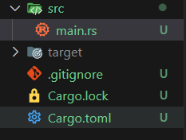

1. Add the **macroquad** library

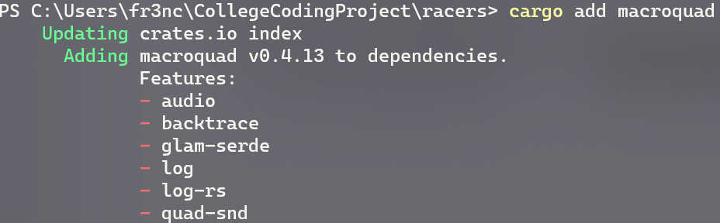

1. Build to project to fetch all the requirements from webserver

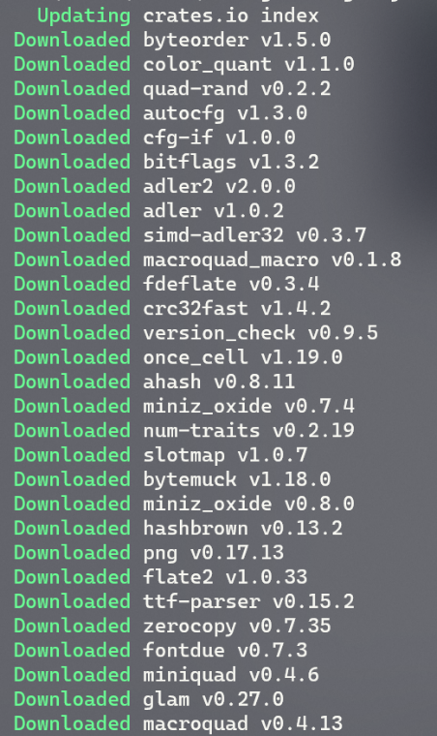

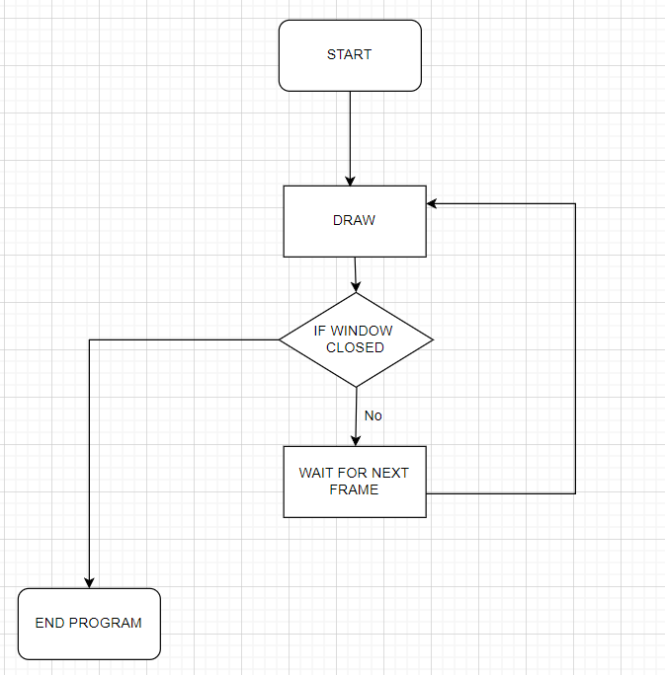Simple game loop architecture

The Boiler Plate Code

This is the code I wrote as a boiler plate which creates a window with any configuration I want. 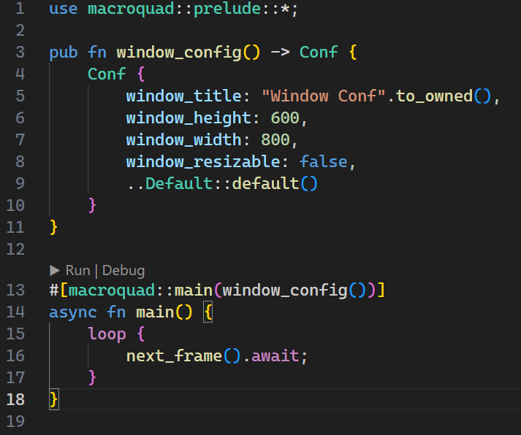

The **use** statement at the top includes most of the macroquad library into the scope of the main program. This allows me to use objects like **Conf** and functions like **next_frame()**. Also something to be noted is that the macroquad library requires the use of a asynchronous main function to run, which is why the main function is labeled as **async.**

The **window_config()** function allows me to choose what specifications I want for the window which is displayed, for example the size at the moment would be 600px by 800px. In the future I plan to move this function into a separate **config** file which separates this type of code into its own section of my project keeping the main file as clean as possible.

This is what the window looks like when the code is run:

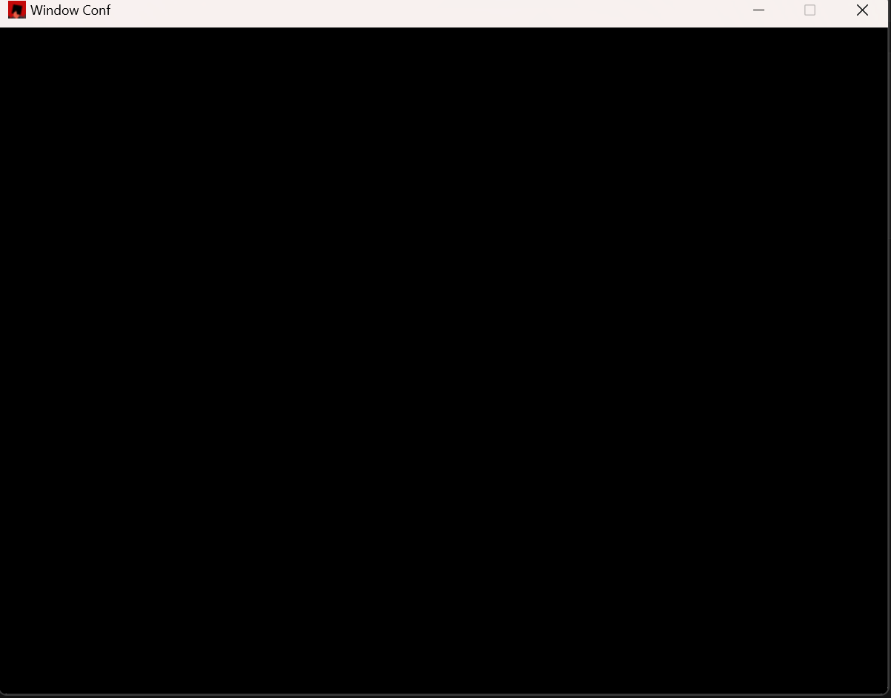

Development 2

*Reminder:* **Stage Two**: Create a car object and draw it to the screen. Implement movement and physics for the car: **steering angle, acceleration, speed, braking**. For development purposes allow movement to be controlled by keyboard.

**Car Object**

Outlining the object, it needs to:

* Move along the screen with velocity, direction and acceleration
* Handle its own rendering, owning its own texture
* Be able to respond to user inputs like steering and accelerating
* Facilitate the use of inputs (weights between 0.0 and 1.0) from a neural network

**NOTE**: Rust doesn’t have classes, but their **structs** are a good enough alternative, so this data is really stored in a **struct** named ‘Car’.

Explanation:

The physical quantities like **Velocity**, **direction, acceleration** and **position** are simple to understand, they are what allow the car to move around the screen any which way it wants.

The **texture** attribute is the graphic which is drawn to the screen and is how we display the cars on screen. The **rect** keeps track of the car’s hitbox so we can tell when it leaves track, hits something etc… It will also be useful in debugging in the future.

**Angle** keeps track of the angle the car is directed at (connected to the **direction**) we use the **angle** to tell the renderer how much to rotate the **texture** before drawing to the screen. **Steer** is the change in angle the **inputs** are requesting, however obviously the angle of the car doesn’t snap to its steering angle so I will use the **steer** attribute as a target for a linear interpolation.

The **Constants** are self-explanatory apart from the steer_weight which is the factor which the **0.0-1.0** **steering** **input** weight is multiplied by to get the actual angle in radians.

The inputs are basically ways of storing the output of a neural network (which should be between 0 and 1) and are multiplied by scalars later to become interpretable values. It difficult to explain and I will come to the use later, when I make the NN. I will also outline the **input** structure next.

|  |
| --- |
| Car |
| **Attributes**  + Velocity: Vector  + Direction: Vector  + Position: Vector  + Acceleration: Vector  + angle: Float  + steer: Float  +texture: Texture2D  +rect: Rect  +accelerator_input: Input  +steering_input: Input  +brakes_input: Input |
| **Constants**  + hitbox_width: float  + hitbox_height: float  + max_speed: float  + max_acceleration: float  + steer_weight: float  + max_turning_angle: float |
| **Methods**  + draw() |
| + update_pos(x, y) |
| + update() |
| + keyboard_control() |
|  |
|  |

Here is the class definition for the car object in rust:

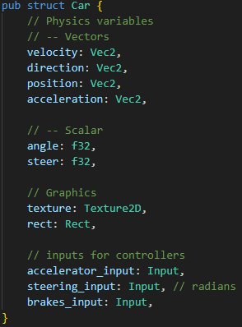

You should be able to compare this to the previously shown class diagram to spot the implementation of each attribute.

I also coded the **Car** class’s constructor, and it is very intuitive to understand, here it is:

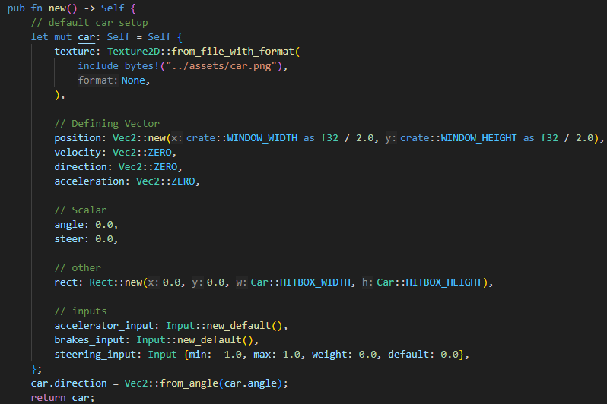

**Note**:

* I used the macroquad Texture2D structure’s functionality to import an asset I found on google for a racing car
* For now, we place the car in the middle of the screen
* We define the rectangular hitbox as macroquad’s predefined **rect** class which offers plenty of useful functionality
* The inputs are initialized as **Input** structs which are basically restricted values which can be set within a certain bound.
* We set the car direction vector by creating a unit vector in direction of the car’s angle.
* Most other physical quantities are set to zero or other arbitrary values

*Deep dive into the methods*

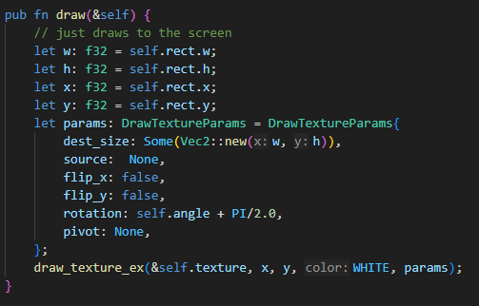

The **draw** function collects the x, y coordinates of the car’s hitbox (which is defined as a Rect class, which is a class included in **macroquad**) then it also retrieves the width and height of the hitbox. These values are passed into draw_texture_ex function which draws the car to the screen. Note we also give the function parameters for rotation since the car should rotate on the screen, but we have to offset the rotation by PI/2 radians or 90 degrees to account for the sprite being at a 90-degree angle. Apart from that it’s a pretty simple function.

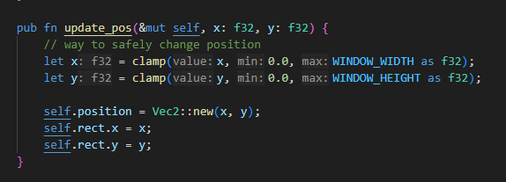

The **update_pos** function takes 2 new coordinates to set the car’s position to, its essentially a *setter*i.e. an public interface to the class’s attributes. It also serves the function of clamping the car to the screen and updating the car’s hitbox **rect** as well as its actual position vector.

**Update** Function

The update function is the main function which controls the behaviour of the car’s physics. It should apply all the physics onto the car object like acceleration, velocity, friction, update position and steering. The steering is the most complex part of the algorithm so I will go into more detail on that.

My update function algorithm in broken English code:

Function Update()

Calculate delta time, to apply to all physical calculations

Calculate how much to steer car

Add steer delta to car’s angle

Calculate new direction vector for car

Calculate car’s acceleration from accelerator input and set its direction to the car’s direction vector

Add velocity to the cars position vector

Update the car’s position using the method

End of function

My update function algorithm pseudo code:

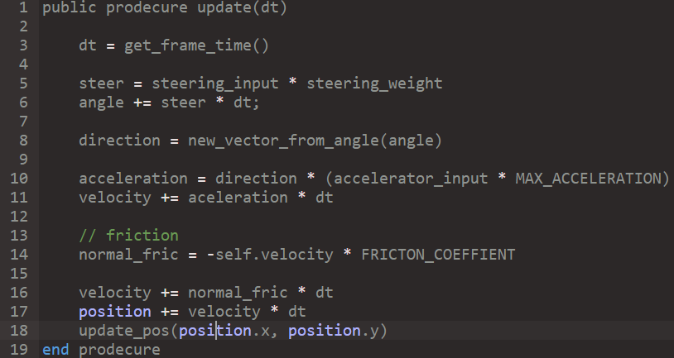

After planning the method in pseudo code I wrote it in rust, note that the key difference between the rust code and the pseudo code is that we need to call methods and attributes using the **self**-keyword and a few variables are given slightly different names for cleaner code. Here it is:

Rust code:

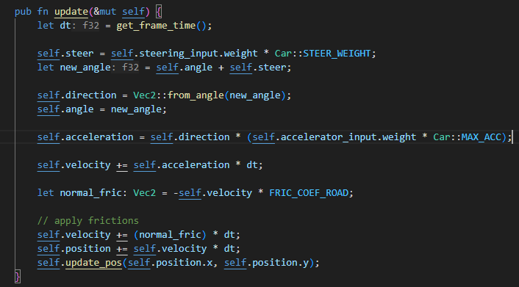  
For now, this update code should be robust enough, however I fully anticipate modifying this function **a lot** since it contains the main bulk of the car’s physical code.

Modifying the Main function

Now we have created the blueprint for a car object, lets create one and update and draw it from the main function.

**Note**: I aim to have only 2 public interfaces to the car class (apart from its creation), which are the **update** and **draw** functions. i.e. the only functions which should be called on the class from outside of itself are the **update** and **draw** functions.

Here is the pseudo code and real code for the main function.

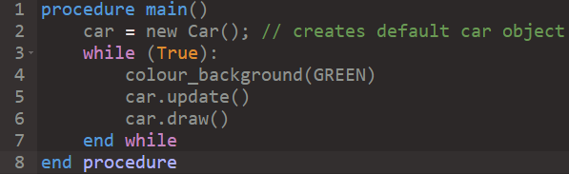

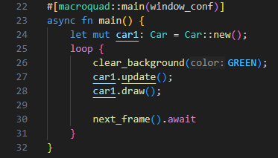

**Note:** The rust code is slightly different, but its just rust’s weird implementation of an infinite loop, and the first scary line is just a bit of macroquad boiler plate (since macroquad requires asynchronous rust to be enabled to run).

Also, I’m fully aware that the main function will change a lot during development and this version is very temporary and mainly for development purposes, but I think it’s important to show what it looks like now since its really the foundation of the project.

*Finally, the user input*

After staring at a stationary car on the screen for a while, I realised that I wanted to implement a way for a **human** user to interact and control the car. Although the car’s will eventually be fully controlled by **AI,** I need to be able to test out the physics before moving onto that implementation, thus *user input* needs to be implemented.

Since its quite an intuitive and temporary method I won’t go into huge detail on it and I will give it to you in rust code:

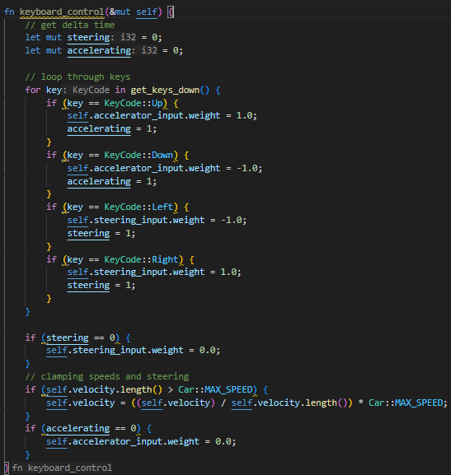

Essentially, for now we are imitating the eventual **neural network’s** inputs using the keyboard for development purposes. Also note that we have two Boolean variables called ***steering*** *and* ***accelerating***which indicates whether the accelerator (forward key) or the steering keys where pressed and if they weren’t set the inputs to **zero**.

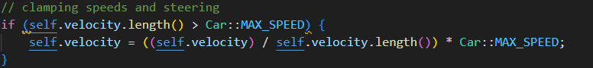

And this section of code caps the speed of the velocity to the car’s predefined max speed.

Now we are ready to test the car physics

Let’s add the user input method into the **update** method

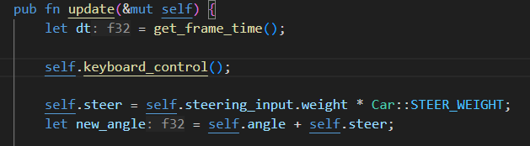

And run the code…

When I ran the code, I noticed that the car would spin instantly when the arrow keys were pressed instead of smoothly rotating, so I added a linear interpolation function to smooth out the rotation.

***The Fix***

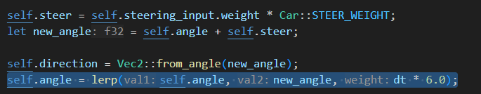

The highlighted line is the modified line. The linear interpolation function requires a factor to say how fast the value should reach the target value, with a bit of tweaking I found that using **deltatime * 6.0** was a good factor for smooth steering.

The video of the running car physics is in “**videos/s2-carrunning.mp4”**

**Link: (**[**Videos\s2-carrunning.mp4**](Videos/s2-carrunning.mp4)**)**

The final thing missing now for the car physics is a braking system. The car should take its braking input and transfer it into a force opposing the car’s motion.

Formula

The brake mechanism will be another frictional component to negate velocity, so we will use a formula which creates an opposing braking frictional acceleration.

**Brake_friction = -velocity * brake_input * brake factor**

The brake factor is a variable used to tweak how powerful the frictional force on the velocity is.

The code:



The result:

[Videos\s2-braketest.mp4](Videos/s2-braketest.mp4)

Testing Stage 2

|  |  |  |  |  |  |
| --- | --- | --- | --- | --- | --- |
| Test no. | Test Description | Test Data | Expected Result | Actual Result | Pass |
| 2.a | Test keyboard input accelerate and friction |  | Press w key and the car will accelerate in the direction of the sprite | It does accelerate and friction eventually brings the car to a stop | Checkmark with solid fill |
| 2.b | Test steering |  | Press a key and the car steers left **only** when moving. And visa-versa for right key. | The steering works as expected, turning its velocity and rotation of sprite | Checkmark with solid fill |
| 2.c | Test braking |  | When the s key is pressed **and** the car is moving, the car’s velocity should close to a stop | The car does brake when the s key is pressed, it slows down quite slowly but the feature does work | Checkmark with solid fill |
| 2.d. | Car sticking to screen |  | When the car hits the border of the screen it should be blocked as if it has hit an invisible barrier | The car does stop but doesn’t act quite as expected, the car sprite can go fully off the screen on the rhs of the screen but on the lhs of the screen it stops as expected. | Close with solid fill |

Results:

The program passed ¾ tests which is a solid result, the failed test is quite an easy fix. Here’s the current code:

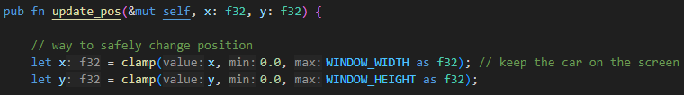

The problem is the sprite’s position is the top left corner of that sprite:

Width = w

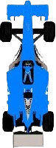

Pos (x, y)

Height = h

The solution:

Pseudo Code

pos.x = clamp(0, ScreenWidth - w)

pos.y = clamp(0, ScreenHeight - h)

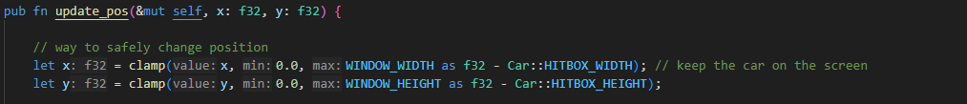Rust Code

End of Stage 2

Development Stage 3

Recap

**Stage Three:** Create a *track* object which handles track limits, drawing itself and checkpoints (which divide the track into sectors)

What is a track?

I think a track object can be defined by a series of points and then we can connect them with lines. To make it look more like a standard track, we can then draw these lines with a large thickness (thickness = road width)

1. Series of dots

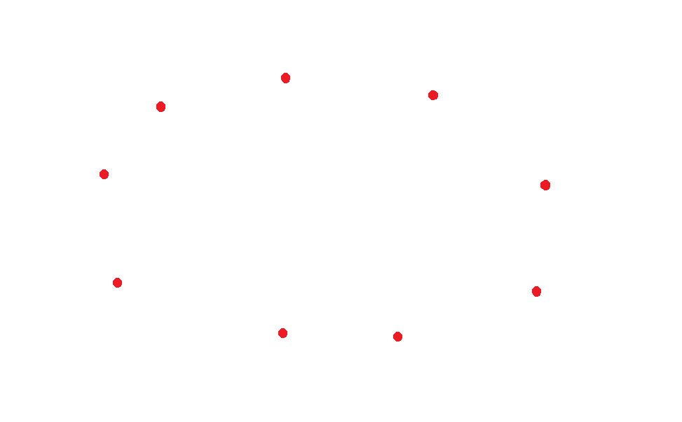

1. Connect the dots

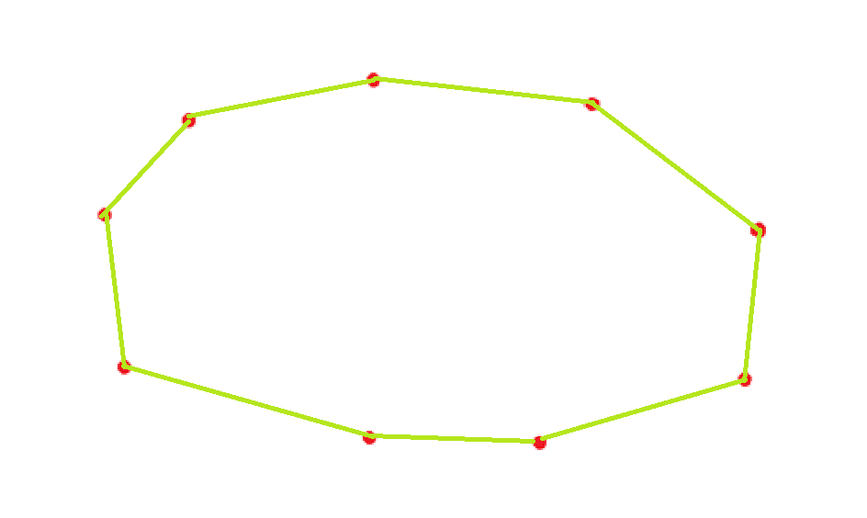

1. 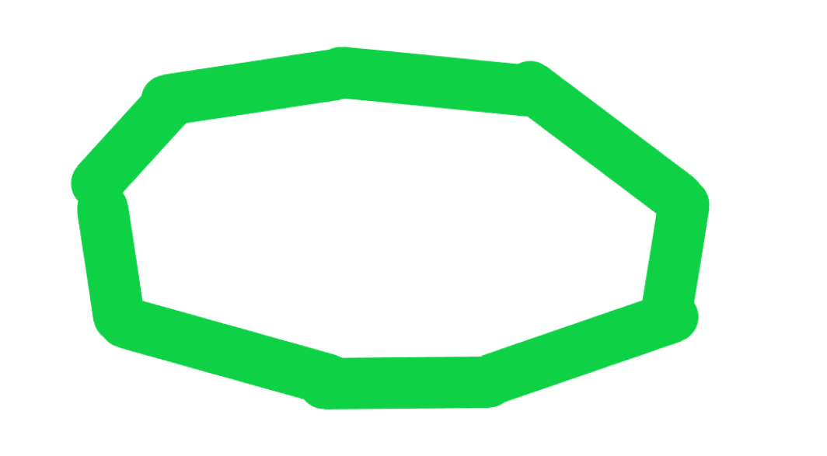Thicker line

I made a little animation in python to visualise and wrap my head around how this would work. The file can be found in

**Documentation/Videos/TrackDemonstrationVid.gif**

The

So now I know what to do, however to define a track as a set of coordinates we need to know the size of the screen, which we should keep as a constant throughout the project.

These values are predefined in the main.rs file but let’s reiterate them in this document.

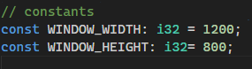

So, our track must lie in a plane of pixels **1200** wide and **800** high.

In this stage of development all I need to do is create a track object so we will save the potential random track generation for later. For now, I will predefine a test track with a set of coordinates.

I think a set of 20 points should be able to define any track I will ever make so I chose the set of points to be an array with size **20.**

|  |
| --- |
| Track |
| Attributes:   * + - points_set: int[2][20] |

Current Track class diagram

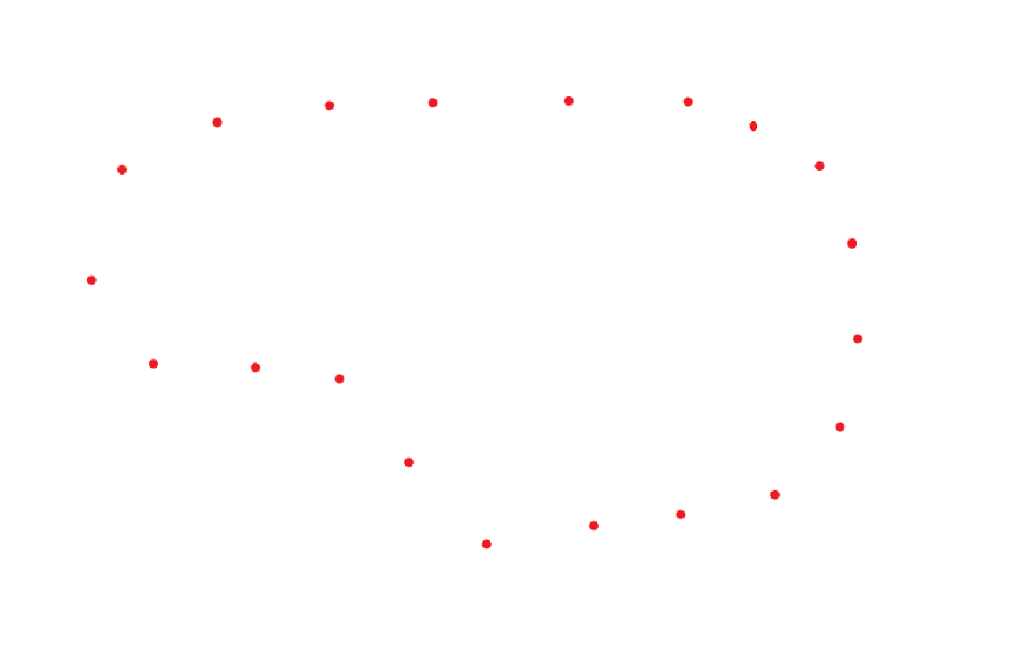I created a test track in paint and copied the coordinates into my track.rs file as a constant array.

**Test Track 1:**

**Code defining the track**

track.rs

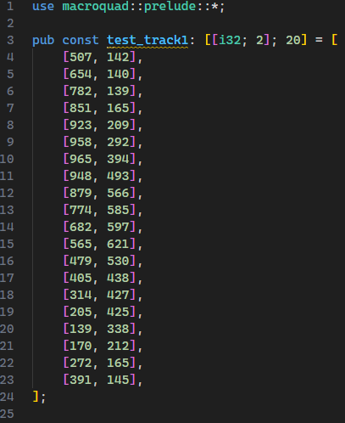

Designing Track Object

Now we have a way of defining a track lets design the class around it.

**The rust structure in code based off of the class diagram from previous page:**

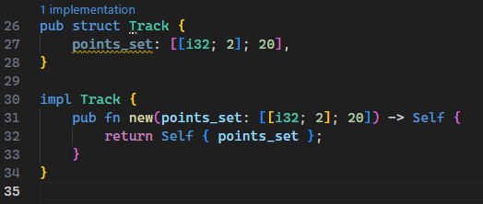

The first functionality I can think of is **drawing the track** so let’s design that function.

**The algorithm**

In English the draw algorithm needs to loop through the set of points, draw lines between them of a given thickness (track width) making sure to draw a line between the first and last points. That is the beauty of it, it should be simple.

**Pseudocode**

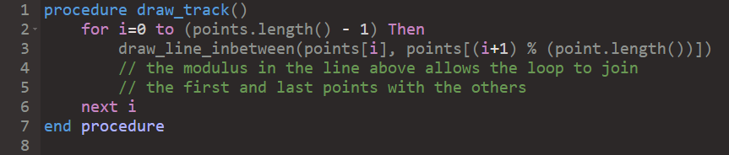

The only bit of complexity here is the modulus described in the code above. It basically means that when the variable **i** reaches the final index of the array **i+1** will loop back to **0,** which essentially means that when the loop finishes it will have joined the first and last point as well as all the others.

When writing the **rust** code, I had to search up how to use a **for loop** in rust and found the answer on [https://doc.rust-lang.org/reference/expressions/loop-expr.html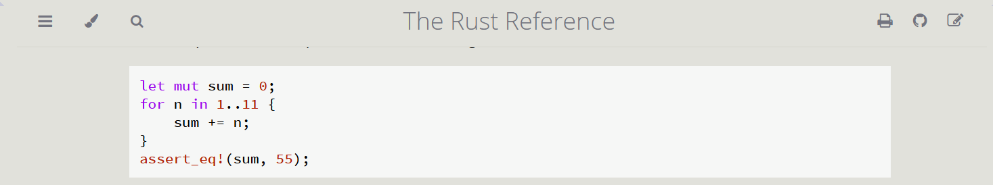](https://doc.rust-lang.org/reference/expressions/loop-expr.html)

Importantly, the range **1..11** loops through 1 to 10 so it’s **not** inclusive on the upper end.

**I also had to look up the draw_line function in macroquad docs:**

<https://docs.rs/macroquad/latest/macroquad/shapes/fn.draw_line.html>

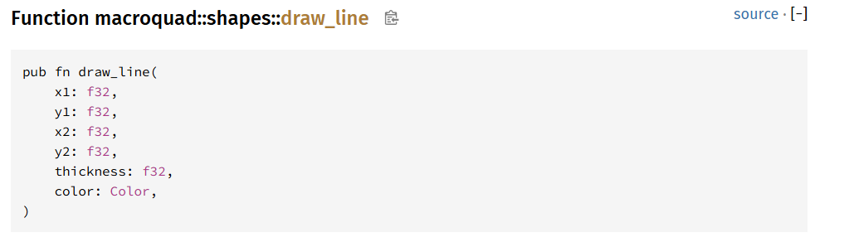

Rust code:

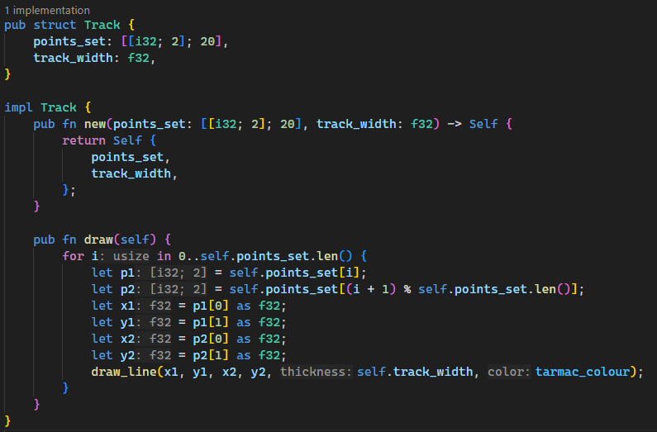

You may notice a new class attribute **track_width** which I added to the track class as a float value. I also added it in the constructor function. Also, I added a constant tarmac colour at the top of the program here:



Updated class diagram

|  |
| --- |
| Track |
| Attributes:   * + - points_set: int [2][20]     - track_width: float |
| Methods:   * + - public procedure draw() |

So, I added a new track object to the main file and called its **draw** function in the main game loop: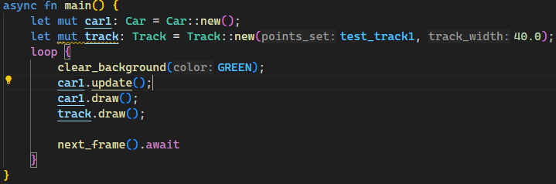

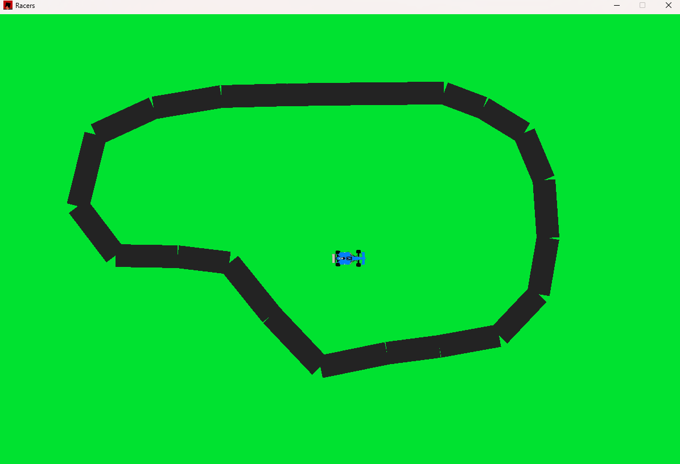However, when I ran the code it was clear something was a tiny bit off:

The lines are draw like rectangles when ideally they would be drawn as a line of circles, (Ill implement that now) and the trackwidth is a bit too small so I just needed to tweak that in the class initialisation line from 40px to 75px.

The bespoke draw_line function I wrote in rust:

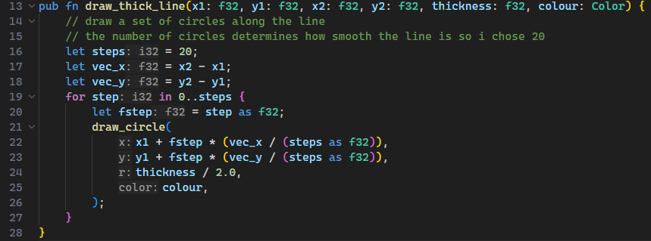

***What it does:***

1. Calculates the vector (x and y components) from the first point to the second point
2. Loop through all steps and draw a circle at a point which is calculated by **the original point + a step through the vector**
3. Draws all 20 circles and then terminates

I made sure to use the same number and order of arguments as the **macroquad** library **draw_line** function so that I could easily switch between both.

Here is the new draw_**thick**_line function used in the **track.draw()** method:

**

*The commented-out line is the previous draw_line library implementation*

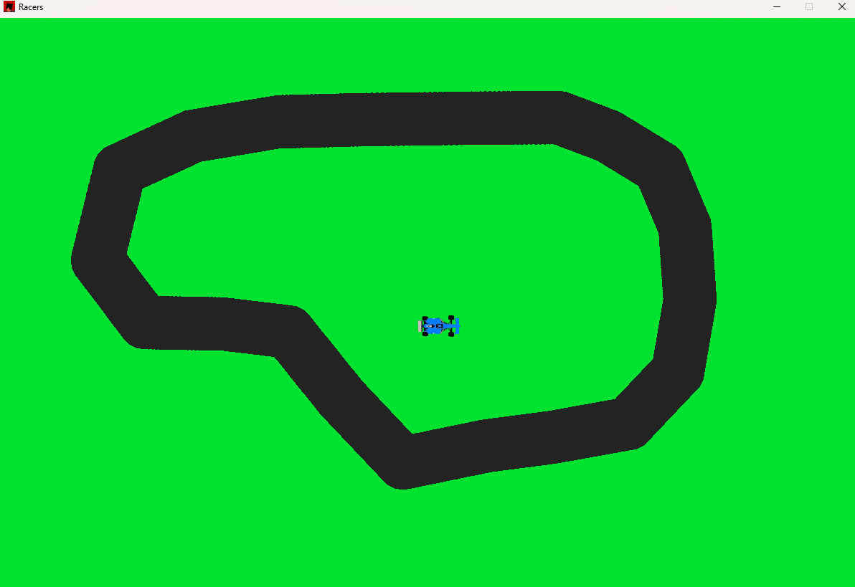The new result

Now that we have drawn quite a beautiful looking track now we can implement the checkpoint system.

**My idea:**

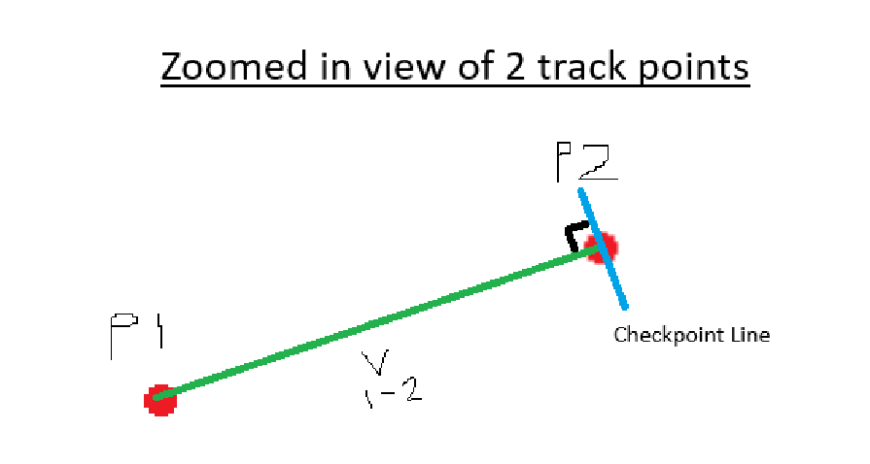

The diagram shows 2 adjacent track points and where the checkpoint line should be drawn. As you can see the checkpoint line is perpendicular to the vector line joining previous point (p1) and the current point (p2).

So, the direction of the checkpoint line can be calculated using some maths (which consequently I have been learning in further maths a level recently).

**Let P2 = (x2, y2)**

**Let P1 = (x1, y1)**

**∆x = x2 – x1**

**∆y = y2 – y1**

**The normal vector is (-∆y, ∆x)**

So now we have an expression for the normal vector direction. However we need to limit its length to **track_width**.

**Let normal vector = n**

**Checkpoint Vector = n/|n| * track_width**

The n/|n| is the normal vector divided by its magnitude creating a unit vector in the same direction. Multiplying that by the track_width will give you an aptly sized vector.

Pseudo code

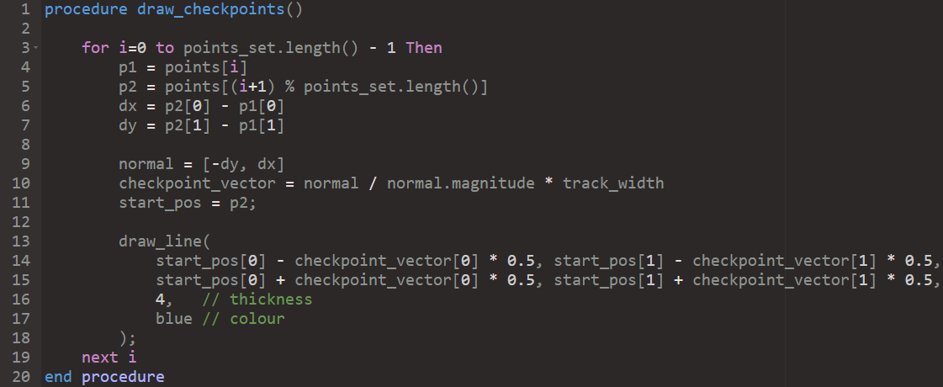

After writing this I decided to rewrite some of the track code to use a predefined struct called Vec2 which stores a x and a y component, rather than using an array of length 2 because it would make the code much more readable. The Vec2 object also provides some useful functionality which I would have otherwise had to write myself.

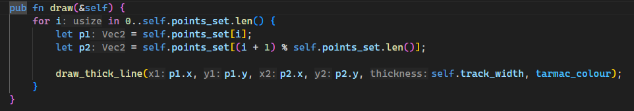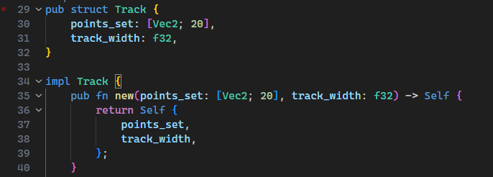

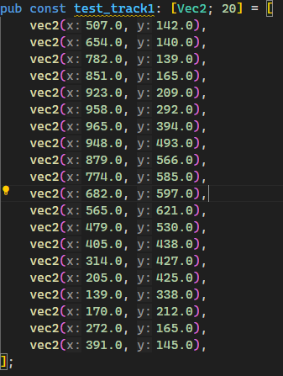Also, a Vec2’s components are float types by default so much of the messy code in the previous draw function can be removed. Overall, changing to this data type will make my code base much more organised. Also note that the new class diagram attribute section looks like this:

|  |
| --- |
| Track |
| Attributes:   * + - points_set: Vec2[20]     - track_width: float |

Finally, the draw checkpoint method implemented in rust:

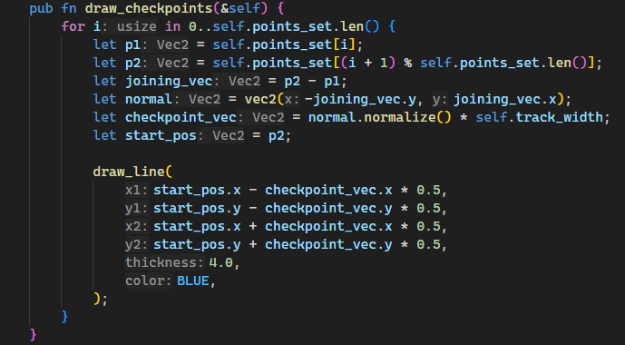

Now let’s run and see the result:

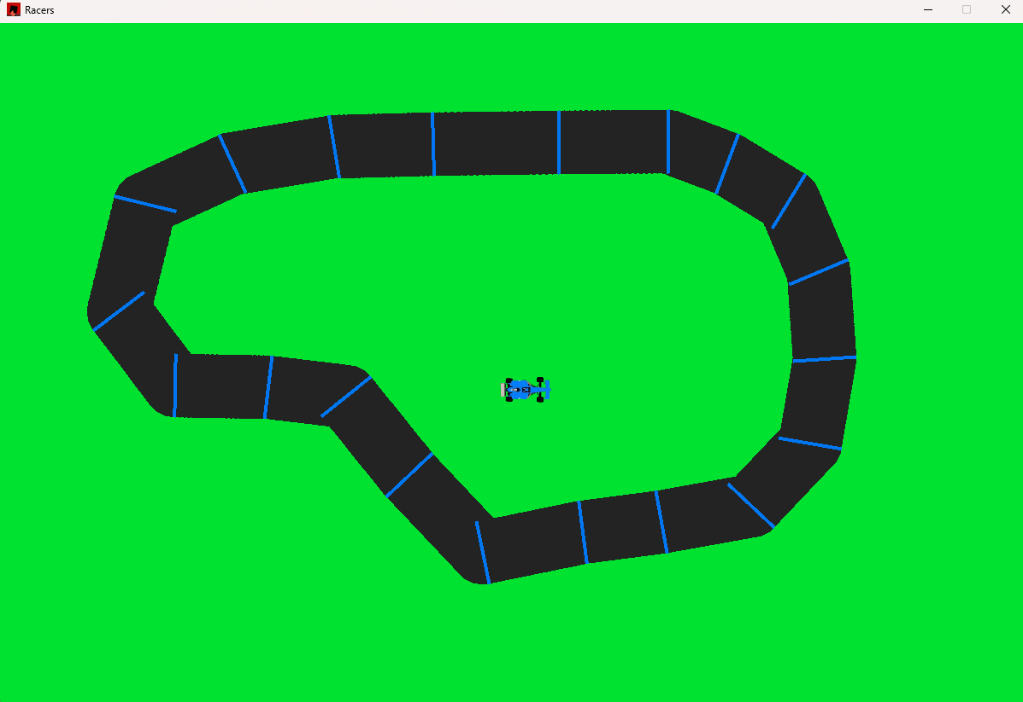

The checkpoint lines are drawn correctly with a little inaccuracy in some places where the line doesn’t quite make it to the other side of the track.

Its going to be pretty impossible to make it completely perfect due to the inaccurate nature of drawing the lines as circles, however I have an idea to increase the accuracy of the lines drawn.

The premise

It works by taking into account the next point in the set of points as well as the last one, calculated both the normals and taking an average of the 2 to create the new line:

Ill just provide the rust code since its quite an intuitive addition:

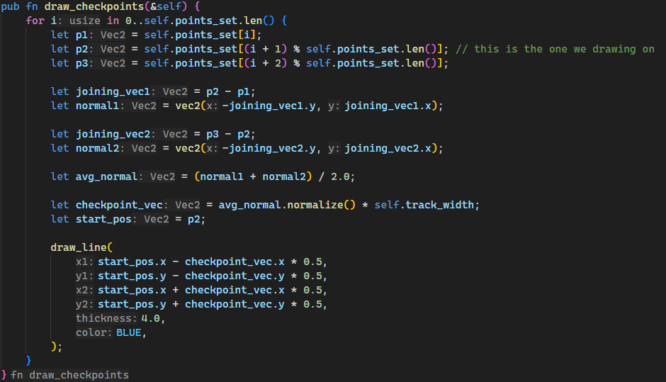

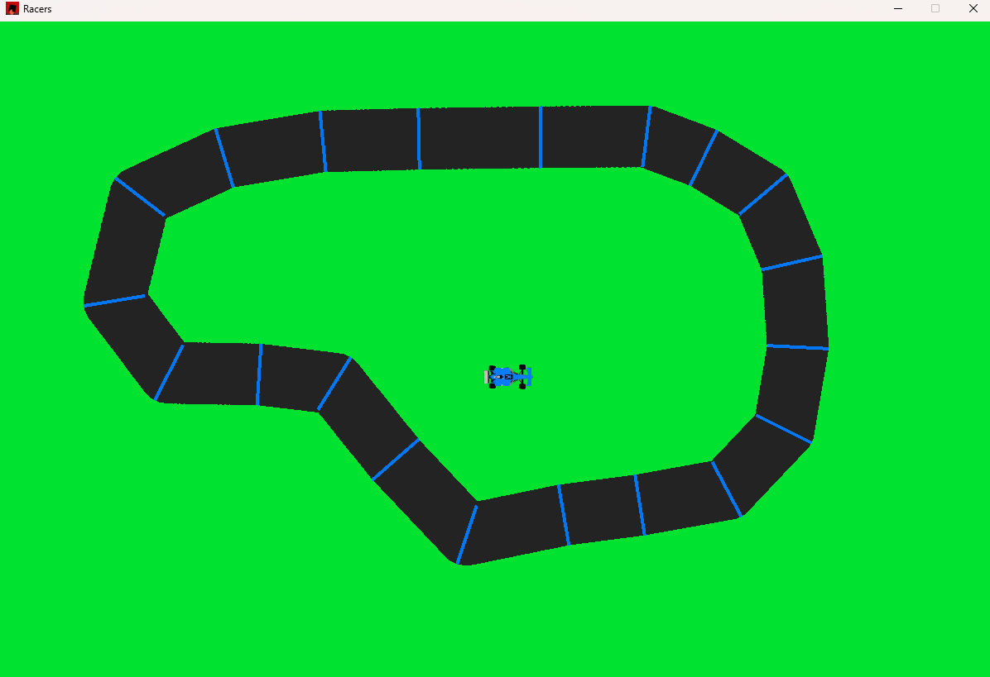The result:

**Clearly much more accurately drawn checkpoint lines now!**

Now the checkpoint drawing function is complete and should be added to the track main **draw** function

When testing this, the car appeared to be underneath the track, suggesting it must be being drawn before the track, when the car should be drawn after the track.

Real time footage of this incident can be found in

*Documentation/Videos/carGone.mp4*



I fixed this and driving on the track footage can be found

*Documentation/Videos/DrivingOnTrack.mkv*

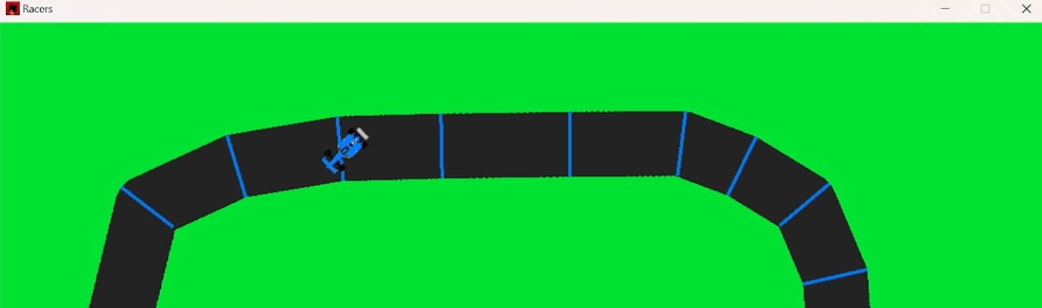

Track limits

To handle track limits, I have decided that an effective solution will be to check if the centre of the car’s hitbox is outside the track. Ie. It the location of the centre of the hitbox is further than **(track_width / 2)** away from its **sector line**. The **sector line** is the straight line which connects the 2 track points the car is in between.

*Diagram* 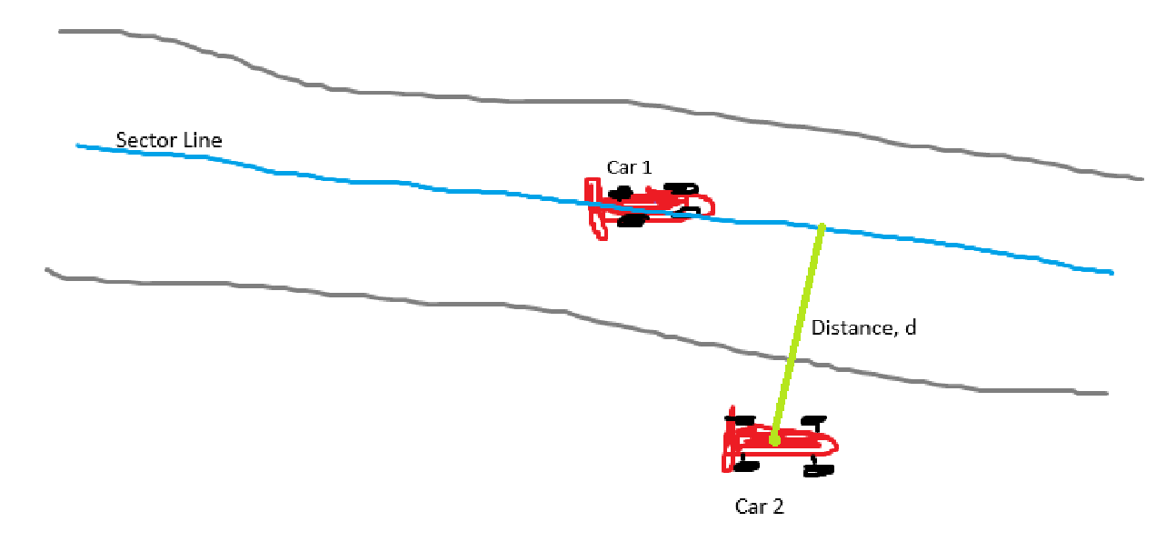

*As you can see the Car 1 is pretty much on the sector line so its definitely inside the track however Car 2 is off the track because the distance from the sector line to its centre is greater than the track_width.*

To actually implement this, we want an **is_on_track** method attached to the **Car** object which can access the **Track** object.

My idea is to have the is_on_track function take a reference to the track object, then the car methods take over the algorithm, they should identify which sector the car is on (closest to) and then further calculate whether the car is on or off the track in the sector.

So, decomposing the problem we need:

* A function to obtain the current sector
* A function to calculate distance to the sector line

*Step 1)*

The **get_sector** functionality for the car given the track object as a reference

The outline of the function is as follows



***Note: The sectors should be numbered 0-19 where sector 0 is the sector between trackpoints 0 and 1, and sector 19 is the sector between points 19 and 0.***

How to do it:

For every sector

* Find the midpoint between the 2 points which define the sector (i.e. if we are on sector **1** then we look at the points **0 and 1.**
* Calculate distance between car’s centre and the midpoint

The sector which gives the shortest distance is the current sector

Implementation

First, I created a getter function which returns a reference to the **Track’s** points_set attribute

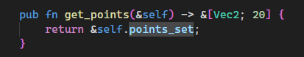

Then I wrote the **get_sector** code.

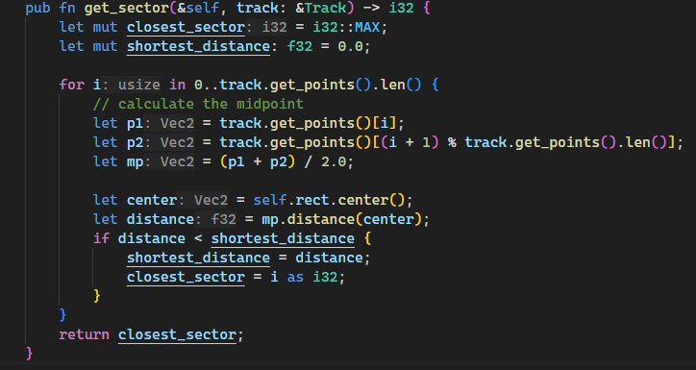

To test the code, I ran it with a print message as shown

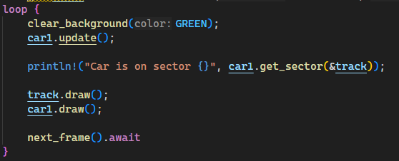

*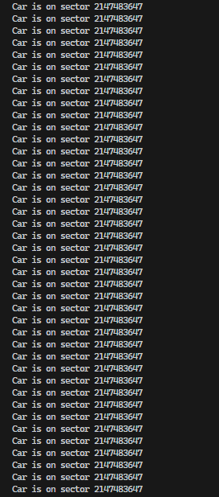However,* ***this*** *was my terminal:*

Clearly this is not a correct result, however when I inspected the function again I realised a simple error in the code

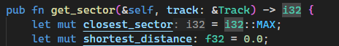

I mixed up the top two variables, the closest_sector should be **0** at default and the shortest distance should be at **f32::MAX** – which is the *largest possible 32-bit float* - at default (it should be as large as possible so any other distance will override it).

I swapped those values around and now the fixed code looks like this

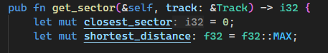

I also decided to highlight the car’s sector to make it easier to understand the output of the function.

After fixing a few silly errors the system worked great! The running video of this working can be found in:

*Documentation/Videos/SectorHighlighting.mkv*

Step 2)

*Finding distance to the sector line*

The only tough bit about this is the calculation to find the perpendicular distance from a line (vector) to a point. However, there is a pretty simple formula to compute this distance, I found this formula on [brilliant.org/wiki/dot-product-between-point-and-a-line](https://brilliant.org/wiki/dot-product-distance-between-point-and-a-line)

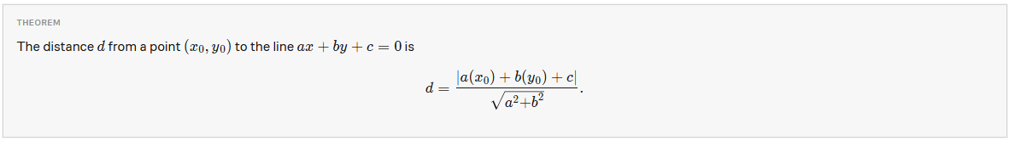

To find the equation of the line of the track sector we need to make a new function which takes in the two points calculates a gradient and finds the values of **a, b and c** in the formula above. To make computing this easier let’s say that **b** is 1 so we just find an equation in the form

y = mx+d

and then rearrange it, to find **a and c**. This means that **m** is the gradient (which is easy to compute) and then we can find **d** using simple maths.

*Pseudocode of this:*

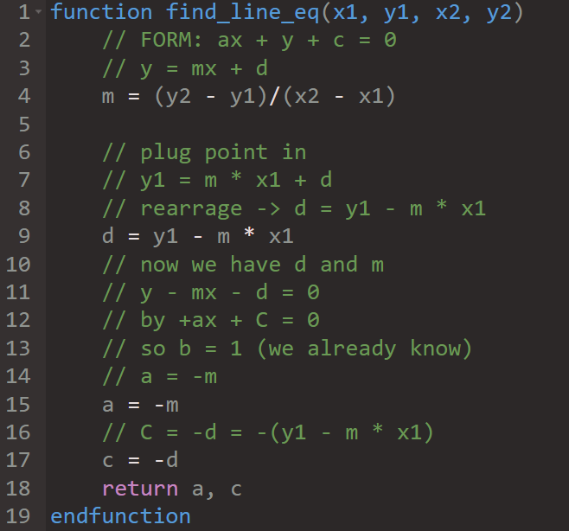

The maths is very simple but I tried to comment it in any way to explain my thought process to myself.

Here’s the function now converted to rust:

Note: I put useful global function like this into a file called utils.rs so that they exist in their own section of the code base in order to declutter the main files.

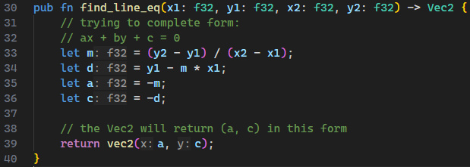

Testing this function

Test Data, Expected result, actual result

|  |  |  |  |
| --- | --- | --- | --- |
| Test Data | Expected Result | Actual Result | Result |
| (3, 5), (4, 6) | A = -1, C= -2 | A = -1, C= -2 | **Pass** |
| (-5, 2), (19, 20) | A = -0.75, C=-5.75 | A = -0.75, C=-5.75 | **Pass** |
| (0, 0), (0, 0) | A = NaN, B = NaN | A = NaN, B = NaN | **Pass** |

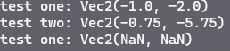Output ->

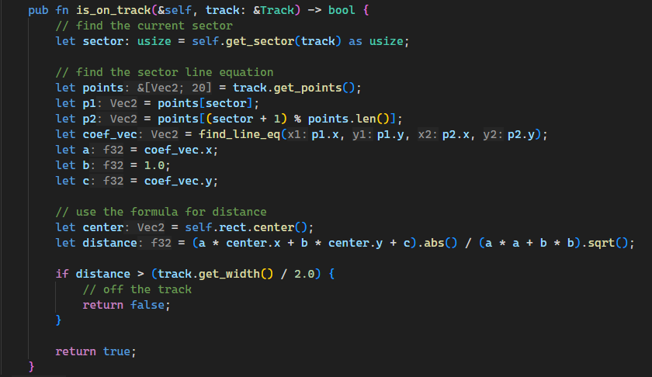 Now it’s safe to use it in the main **is_on_track** function. Now we can find the perpendicular distance from the centre of the car to its nearest sector line so we can write the whole function:

I also had to add another getter for the track object, **get_width()**:

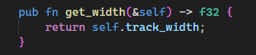

Now I will add a print alert to show whether the car is on or off the track and run the code!



The function worked perfectly (which really surprised me) and the footage can be seen in:

*Documentation/Videos/TrackLimitTesting1.mkv*

Finally, I removed the temporary code which highlights the sector that the car is on and I tweaked the tarmac colour to be slightly lighter as well as the checkpoint colour.



